Conservation Area Appraisal
Church Road, Tadley

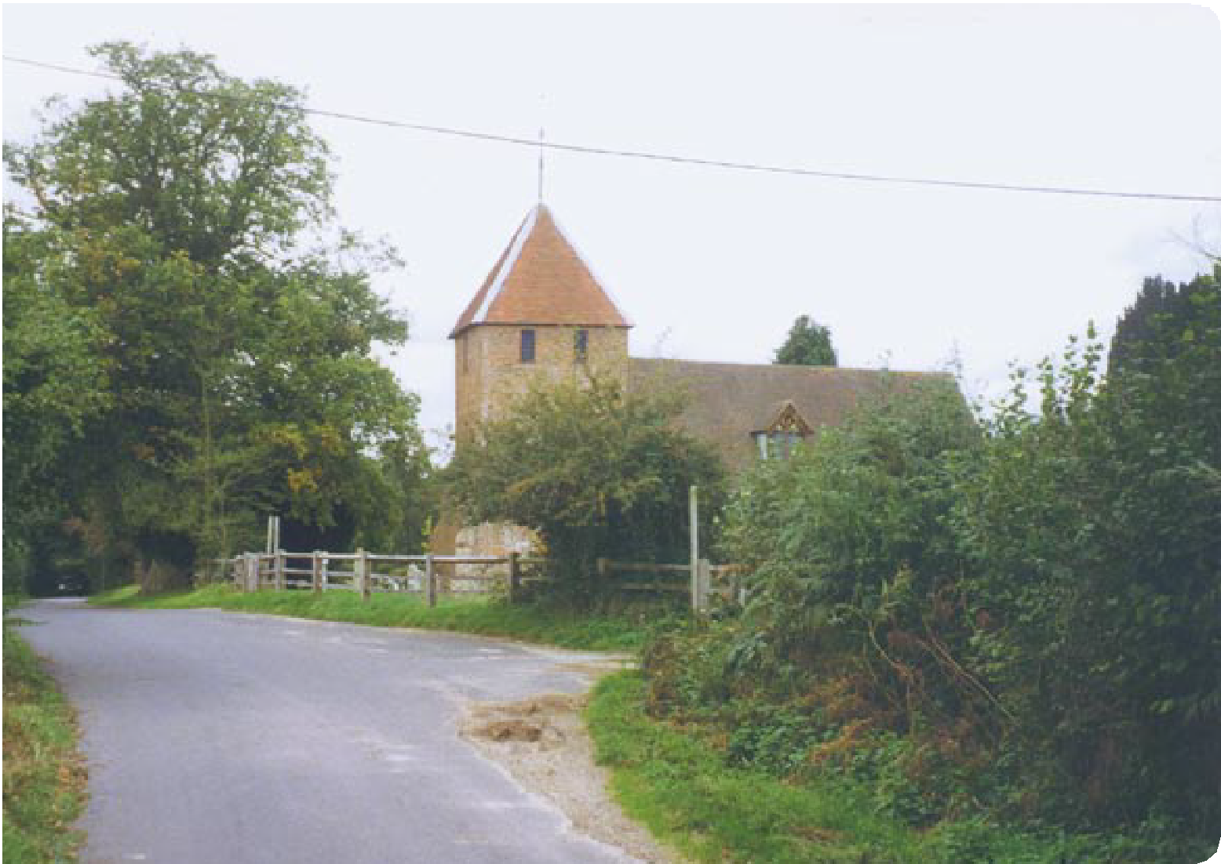
…making a difference

Conservation Area Appraisal

Introduction
Basingstoke and Deane Borough Council designated the Church Road, Tadley Conservation Area in 1982 in recognition of the special architectural and historic interest of the village.

Having designated the Conservation Area, the Local Authority has a statutory duty to ensure that those elements that form its particular character or appearance should be preserved or enhanced, especially when considering planning applications.

View to Hawley Farmhouse

View into the village
It is therefore necessary to define and analyse those qualities or elements that contribute to, or detract from, the special interest of the area and to assess how they combine to justify its designation as a Conservation Area. Such factors can include:

- its historic development;

- the contribution of individual or groups of buildings to the streetscene and the spaces that surround them; and

- the relationship between the built environment and the landscape.

They can also include the less tangible senses and experiences, such as noises and smells, which can play a key part in forming the distinctive character of an area.

The Appraisal takes the form of a written text and an Appraisal plan. In both respects every effort has been made to include or analyse those elements that are key to the special character of the area. Where buildings, structures or features have not been specifically highlighted, this does not mean that they are of no visual or historic value to the Conservation Area. The document is intended to be an overall framework and guide, within which decisions can be made on a site-specific basis.

This Appraisal of the Church Road, Tadley Conservation Area follows its review in 2003 and explains what its designation means for those who live and work in the area.

This document was adopted as Supplementary Planning Guidance by the Borough of Basingstoke and Deane on 17 July 2003 and complements the policies of the Borough Local Plan (review).

It has been subject to consultation with Councillors, the Town Council and local amenity groups. A full list of consultees, copies of their responses, and details of the Council’s consideration of the issues raised during the consultation period are available for inspection, by appointment, at the Civic Offices, during normal office hours.

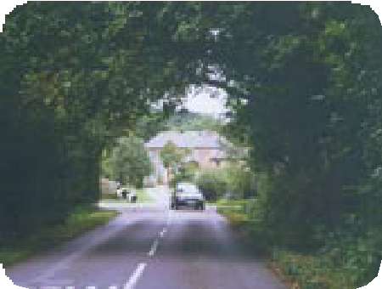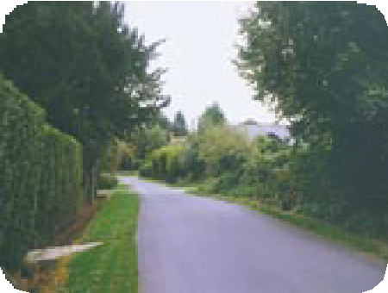

2 Church Road, Tadley

Conservation Area Appraisal

Location and Population
The main settlement of Tadley is located in the north of Hampshire, approximately six miles north-west of Basingstoke. The main A340 road runs north/south through the settlement, and to the east is Pamber Forest. The Church Road Conservation Area is located approximately one third of a mile to the west of the main settlement. It extends from the medieval church of St Peter at its southern end, to New Road (approximately one mile to the north).

The population of the Conservation Area in 1998 was approximately 36 (projection based on the Hampshire County Council Planning Department Small Area Population Forecasts).

Historic Development

Settlement Origins
The name Tadley has possible origins from several old English words. ‘Tad’ may have meant toads, or could be derived from a personal name. ‘Ley’ is generally interpreted as meaning meadow or pasture.

Tadley (Taddanleage) is first mentioned in a charter dated AD909, granting Bishops Wood to the Bishop of Winchester. Tadley did have an independent manor of its own, initially called Tadley, and later named the manor of Withford or Wyeford. In 1166 the manor was the property of William Hotot. In 1305 it passed to the de la More family and, in 1496, the Ludlow family inherited the manor through marriage. Henry Ludlow was the Lord of the Manor in 1625. He is said to have pulled down, or destroyed, the original village of Tadley which may have been located in the vicinity of St Peter’s Church, forcing the villagers to move to the present site of ‘Old Tadley’.

Another theory for the relocation of the village at this time was the resurgence of the Black Death in this area of country. The establishment of The Old Meeting House, and the increasing support for the non- conformist religions, drawing villagers away from the traditional area of settlement, may also have been responsible. After the death of Henry Ludlow in 1639, the history of the manor is uncertain. By the end of the 17th century it had passed into the hands of the Wither family, who retained the property for some time.

Settlement Development
Although the north of Tadley was primarily healthland and commonland, the area of Church Road, and west and south of this, was and still is primarily agricultural.

Until World War II, Tadley comprised the area of settlement covered by the Tadley Conservation Area. However, the development of the Aldermaston Airfield, during the war, and the subsequent arrival of the

Garden Cottage

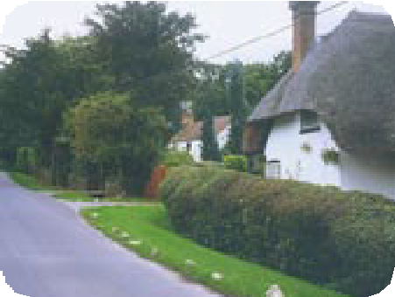

Church Road, Tadley 3

Conservation Area Appraisal

Atomic Weapons Research Establishment (AWRE) in 1950, encouraged development northward, forming the present town.

Historically, Tadley inhabitants were dependant on the woodland crafts associated with Pamber Forest. Villagers provided coppiced timber for use in the making of hurdles, barrels, baskets, kindling and the renowned besom brooms. Bricks were also made on Tadley Common. The Church Road area was largely dependent on agriculture, and this is still a dominant influence on the appearance of the Conservation Area.

St Peter’s Church

An Appraisal of the Conservation Area

An Overview
The Appraisal plan identifies those buildings, views and key features considered essential to the special character or appearance of the Conservation Area. In addition to listed buildings, it also includes unlisted buildings of particular individual or group value, which are indicated on the Appraisal plan as notable. This is not to undermine the value of other unmarked buildings or structures that reflect the historic development of the village without detracting from its special qualities.

Individual hedgerows have not been included in the Appraisal plan. However, their contribution to the character of the Conservation Area should not be underestimated, and their significance is implicit in the Appraisal.

Built Form
There are six buildings located within the Conservation Area included in the Statutory List of Buildings of Special Architectural or Historic Interest. St Peter’s Church is Grade I listed, and is of outstanding national importance. The remainder are listed as being of special local or regional importance (Grade II). Their large form and arrangement within large open plots is in sharp contrast to the neighbouring town of Tadley.

The listed buildings represent a variety of building types, mainly dating between the 16th and 19th centuries. Dispersed throughout the Conservation Area, and often located at key visual points in the streetscene, they make a significant contribution to the special qualities of the Conservation Area.

There are several unlisted buildings that contribute positively to the special character of the Conservation Area. These buildings, dating mainly from the 19th century, are scattered within the landscape. Whilst some have intrinsic architectural or historic merit, most are highlighted for their group value in reinforcing the character of the Conservation Area. Historic buildings of
particular individual or group value are indicated as notable on the Appraisal plan. Other unmarked buildings or structures may also reflect the historic development of the area, without detracting from its special qualities.

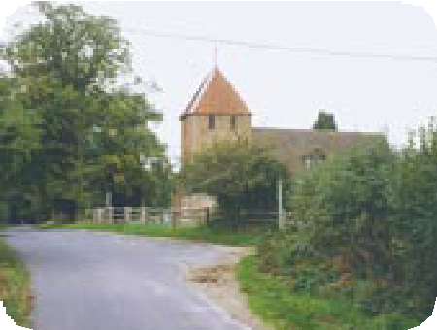

4 Church Road, Tadley

Conservation Area Appraisal

Key Individual Buildings
St Peter’s Church dates mainly from the 17th and 18th centuries. It was restored extensively in 1879 and has an aisleless nave and chancel, a west tower, and a south porch. There is a reference to a church at Tadley in AD1286 and of a vicar of Overton with Tadley in AD1303. The chancel has brick walling in Flemish bond with blue headers, and a 19th century three- light wooden perpendicular style east window. The nave is roughcast, with coupled round-arched windows, a plain filled-in arched doorway on the north, and a larger arched doorway into the porch. The tower has a pyramid shaped tiled roof and red brick walling in English bond.

The church lies at the top of a small incline in Church Road and can, therefore, only be seen from the north when the narrow, hedged country lane widens as it reaches this point. From the south, the church again only appears as the trees and hedges that define the lane give way to reveal the tower.

Hawley Farmhouse dates from 1823 and has a symmetrical façade, which is imposing and polite, and of intended status. The roof is hipped slate with brick dentil eaves, and the walling is blue headers with flush red dressings and rubbed flat arches. The farmhouse is an important feature of the Conservation Area. It terminates the long, tree-lined corridor view along New Road from the bend in the road past No 94 at the edge of the area. It can also be glimpsed from across the fields to the west of Church Brook and from Church Road.

To the east of the farmhouse lies a granary dating from the early 19th century, which has been substantially altered for use as a barn. It is constructed of a two bay timber-frame, with a half hipped tile roof and boarded walling. The enclosed setting of this farm complex, behind a mature tree belt on New Road and Church Road, is an important characteristic. It places the buildings in a well-defined space, separated from the open rural space beyond.

Hatch Cottage, situated close to the church, dates from the 16th century and is a cruck built timber-framed house of one-storey and an attic. The roof is thatched with three-eyebrow dormers, and the timber-frame is exposed on the north gable.

Notable unlisted buildings within the Conservation Area include Bishopwood Grange, the agricultural buildings at Hawley Farm, Foxley Barn, Coachman’s Cottage, and Garden Cottage. Often only the slopes of their thatched roofs are visible above tall boundary hedges, which help create their mature and formal landscape settings. These buildings are generally of simple vernacular form and individually reinforce the historic character of the settlement.
Hawley Farmhouse

Hawley Farmhouse granary

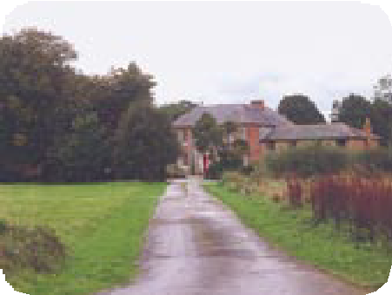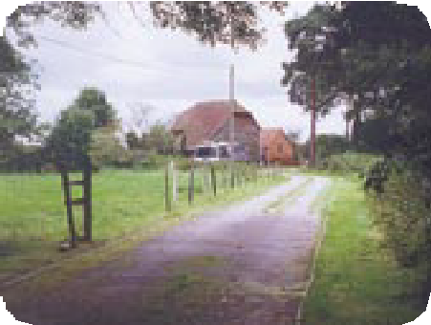

Church Road, Tadley 5

Conservation Area Appraisal

Hatch Cottage

View to Hawley Farmhouse

Significant Groups of Buildings
Situated a short distance apart, in the middle of the Conservation Area, are Pound Farmhouse and Barn Close House. Pound Farmhouse dates from the late 18th century and is a two-storey building with a tiled roof. The walling is red brick in Flemish bond, and there is a massive chimneystack at the west end. The windows are all casements with leaded lights and cast iron frames. Barn Close House dates from the 18th century, with 1878 alterations by Reverend Saulez to become the earliest known rectory. It is of two-storeys with a tiled roof and tapered end chimneystacks. The walling is roughcast with end pilasters and cambered window and door openings. The casements have pointed, coupled lights with rectangular frames, and there is evidence of an earlier timber- framed structure.

Building Materials
The buildings within the Conservation Area demonstrate the range of vernacular materials prevalent throughout all periods of development. The retention of thatch as a roofing material is especially important in maintaining the distinctive character of the area.

Given the domestic scale and simple provincial architecture of the buildings in the Conservation Area, historic joinery (such as sash windows, doors and door hoods) often defines the appearance of properties. This is also the case for the more grand or ordered elevations as at Hawley Farmhouse where the arrangement of sash windows is key to the architectural design. Although some buildings have been modernised, the use and overall effect of inappropriate replacement windows and doors is limited.

The Character and Importance of Public and Private Spaces
The open spaces in the Conservation Area are extremely important as they create the pattern of settlement and reinforce its historic rural character and appearance. The open areas surrounding Hawley Farm allow it to remain in its traditional rural setting. There is an area of countryside between Barn Close House in the north, and Hatch Cottage in the south. This provide extensive views across the surrounding landscape to the south-west and west. There are also restricted views to the east and north.

Smaller cultivated areas, such as gardens, also create important settings to the many buildings set back from Church Road. The uncurved verges along parts of the road help define the residential character of the road. Mature trees are planted around the Conservation Area, both singly and in avenues. They line the roadside along Church Brook, and

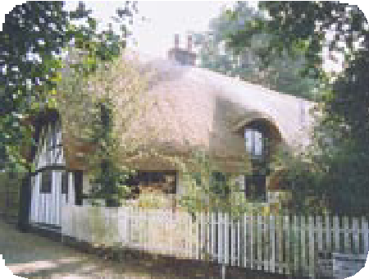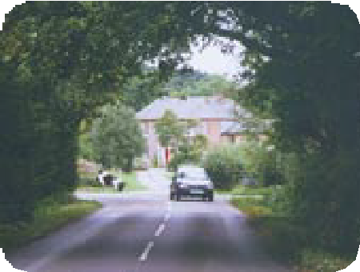

6 Church Road, Tadley

Conservation Area Appraisal

are also in plantations to the west of the area. The verdant character of the Conservation Area, together with the narrow lanes and hedges (particularly towards the church), restricts long views. Ash and oak are the dominant species, with birch, willow, alder, walnut, beech, holly and robinia. Scots pine and yew trees are also present. Generally the tree cover in the Conservation Area is broadleaved in character with only
a few conifers scattered around. The verges to the roads are generally hedge-lined, with some hedgerow trees in evidence, creating a tunnel- like effect.

The Setting of the Conservation Area
The Conservation Area has two very different neighbouring areas. They are the post- war development of Tadley to the east and north, and the open countryside to the south and west. The area is therefore visible, if not
discernable, as a distinctive place from the countryside and can be seen when approached from Tadley. Little of its surroundings can be viewed from inside the Conservation Area. This is due to the combination of the tall and dense wooded areas on the edges, and the lack of any topographical features of note.

Areas of Archaeological Significance
Every settlement contains within it archaeological evidence of its origins and development, the economy and industry of the community and of the lives and lifestyles of past inhabitants. It is in the Areas of High Archaeological Importance (AHAP) that it is most likely that such archaeological remains will most likely be encountered. Where a development is proposed, the impact that it might have on these remains is a material consideration within the planning process. This may occasionally result in the need for archaeological recording in the case of some developments.

The archaeological significance or potential of the Conservation Area has yet to be identified. However, the possible historical development of Tadley suggests that an area in the vicinity of the church may have been the origin of the settlement.

Low Bridge on Church Road

View along Church Brook

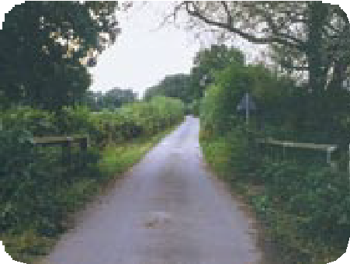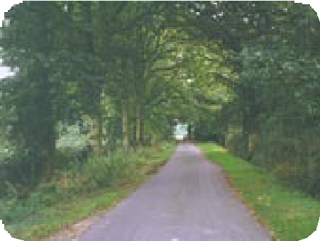

Church Road, Tadley 7

Conservation Area Appraisal

Conservation Area Planning Controls
The following controls apply within the Conservation Area in addition to normal planning controls:

- Conservation Area Consent is normally required for the demolition of buildings or structures over a certain size within a Conservation Area

Pound Farmhouse

Hawley Farmhouse
- The Council must be given six weeks notice of any intention to undertake works to, cut down or uproot any trees over a certain size in the Conservation Area

- Planning applications which, in the opinion of the Borough Council, would affect the special character of the Conservation Area must be advertised and the opportunity given for public comment. This may include proposals outside the Conservation Area which nevertheless affect its setting

Statutory policies relating to Conservation Areas and listed buildings are set out in the adopted Basingstoke and Deane Borough Local Plan. These policies reflect the statutory duty on the Local Planning Authority to have regard to the preservation of historic buildings or their setting, and to the enhancement of areas designated as being of special interest. These policies seek to ensure that particular attention will be paid to the scale, height, form, materials and detailing of proposals including boundary treatments and other features of note. In order to consider the implications of development, and given the detail required, the Borough
Council will normally require proposals within the Conservation Area to be submitted in the form of a full, and not outline, application. The Borough Council’s conservation officers are available for advice and information on all matters relating to development proposals in the Conservation Area.

Grants
The Borough Council provides grants for various types of work. These include Historic Buildings Grants, Environment and Regeneration Grants, and Village and Community Hall Grants. Leaflets are available explaining the purpose and criteria for each grant and an approach to the Council is recommended for further information on any grant.

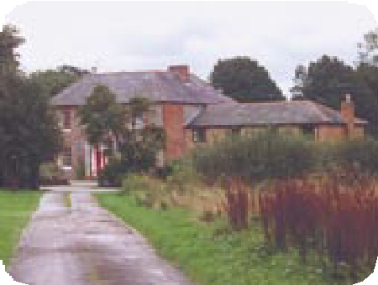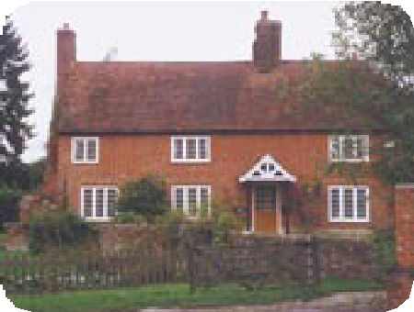

8 Church Road, Tadley

Conservation Area Appraisal - Church Road, Tadley 1870 OS Map

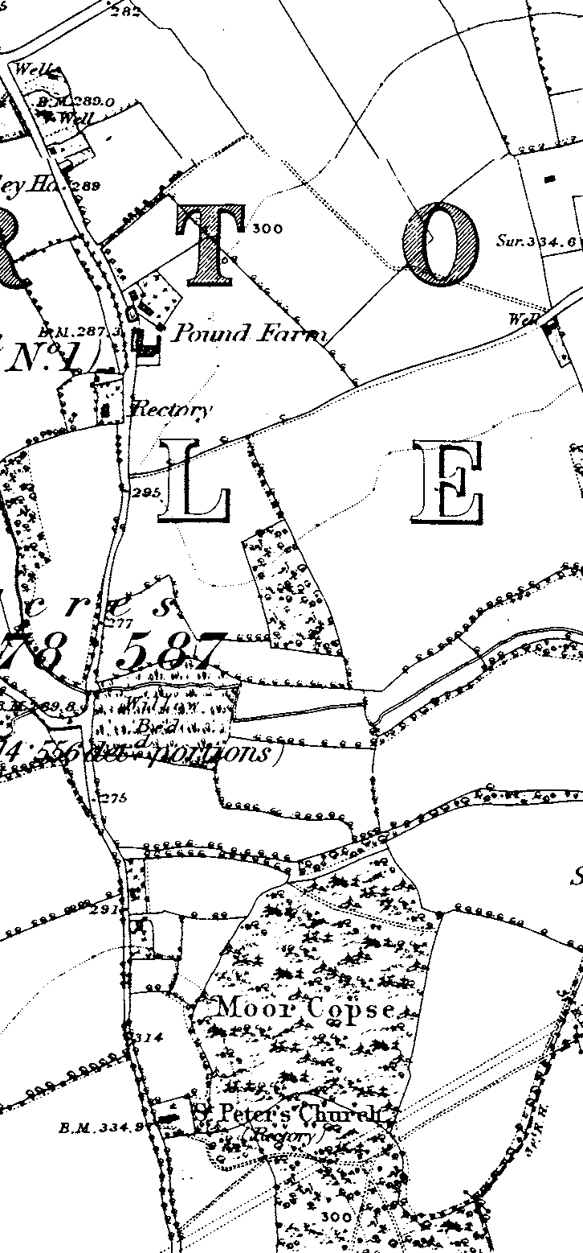

Church Road, Tadley 9

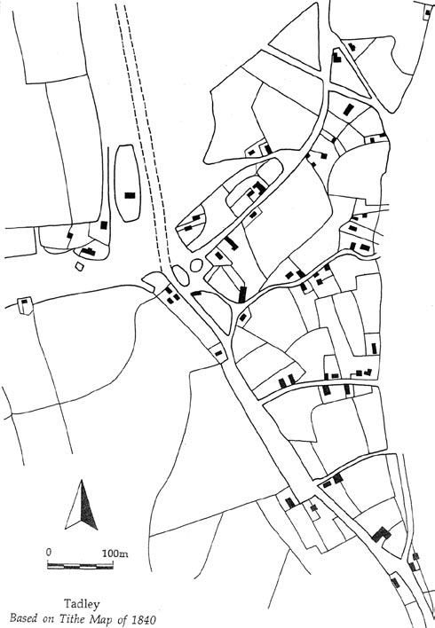
Conservation Area Appraisal - Church Road, Tadley Tithe Map

10 Church Road, Tadley

Conservation Area Appraisal

Introduction
Lorem ipsum dolor sit amet, consectetuer adipiscing elit, sed diam nonummy nibh euismod tincidunt ut laoreet dolore magna aliquam erat volutpat. Ut wisi enim ad minim veniam, quis nostrud exerci tation ullamcorper suscipit lobortis nisl ut aliquip ex ea commodo consequat. Duis autem vel eum iriure dolor in hendrerit in vulputate velit esse molestie consequat, vel illum dolore eu feugiat nulla facilisis at vero eros et accumsan et iusto odio dignissim qui blandit praesent luptatum zzril delenit augue duis dolore te feugait nulla facilisi neque porro quisquam est, qui dolorem ipsum, quia dolor sit, amet, consectetur, adipisci velit, sed quia non numquam eius modi tempora incidunt, ut labore et dolore magnam aliquam
Picture Text quaerat voluptatem.
Lorem ipsum dolor sit amet, consectetuer adipiscing elit, sed diam nonummy nibh euismod tincidunt ut laoreet dolore magna aliquam erat volutpat. Ut wisi enim ad minim veniam, quis nostrud exerci tation ullamcorper suscipit lobortis nisl ut aliquip ex ea commodo consequat. Duis autem vel eum iriure dolor in hendrerit in vulputate velit esse molestie consequat, vel illum dolore eu feugiat nulla facilisis at vero eros et accumsan et iusto odio dignissim qui blandit praesent luptatum zzril delenit augue duis dolore te feugait nulla facilisi.
Pleff lorem monaq morel plaff lerom baple merol pliff ipsum ponaq mipsu ploff pimsu caple supim pluff sumip qonaq issum daple ussum ronaq ossom fap25
Picture Text abcde tonaq fghij gaple klmno vonaq pqrst haple uvwxy nonaq zzzz. Laple pleff lorem monaq morel plaff sumip qonaq issum daple ussum ponaq gaple klm50
lore.

Picture Text

Picture Text

1 Church Road, Tadley

Conservation Area Appraisal
Church Road, Tadley

…making a difference

Basingstoke and Deane Borough Council
Civic Offices London Road Basingstoke Hants RG21 4AH

Telephone 01256 844844 Fax 01256 845200
www.basingstoke.gov.uk
Produced by Graphics/Corporate Information Division April 2004

5228

